**Chapter-1**

**INTRODUCTION**

In the dynamic world of libraries, efficient management of resources and seamless user experiences are pivotal for fostering a thriving reading culture. The Library Management System (LMS) presented herein is a sophisticated and interactive solution designed to transform traditional library operations. This project aims to revolutionize the way libraries handle book cataloging, member management, book borrowing, reservations, and fines.

By leveraging Python's robust programming capabilities and the `datetime` module, the LMS empowers library administrators with a comprehensive toolkit for adding new books, registering members, and displaying the library catalog. Furthermore, the system enhances member interactions by allowing effortless book borrowing, seamless returns, and convenient book reservations, all while calculating fines for overdue books accurately.

The LMS is crafted with user-friendliness in mind, ensuring an intuitive and engaging experience for both administrators and library patrons. With the potential for future integrations, scalability, and security enhancements, this project lays the groundwork for an innovative and modern Library Management System that optimizes library operations and amplifies the joy of reading for every user. In an era marked by digital transformation, the Library Management System represents a paradigm shift in how libraries adapt to evolving user needs. The incorporation of the `datetime` module enables precise fine calculations for overdue books, ensuring fair and transparent processes. As libraries strive to create inclusive spaces, this project also sets the stage for potential integrations with mobile applications, broadening accessibility and engaging patrons on their preferred devices.

With its emphasis on data-driven decision-making and automation, the LMS empowers librarians to optimize collection development, resource allocation, and operational efficiency. Moreover, the inclusion of exception handling in the code guarantees robustness, effectively addressing potential errors and offering a seamless user experience. As libraries embrace the digital age, this innovative Library Management System serves as a pivotal step towards enriching library services and nurturing a vibrant reading community.

**Chapter-2**

**LITERATURE REVIEW**

**1. A Comparative Study of Library Management Systems**

**Summary:** This research paper presents a comprehensive analysis and comparison of various Library Management Systems available in the market. The study evaluates different features, functionalities, and user interfaces of the systems to identify their strengths and weaknesses. The research aims to help libraries choose the most suitable system that aligns with their specific requirements and budget constraints.

**2. Impact of Library Management System on Library Efficiency**

**Summary**: This study examines the impact of implementing a Library Management System on the efficiency of library operations. By collecting data on book circulation, cataloging, and member management before and after system implementation, the research demonstrates how automation and streamlining of processes lead to significant time savings and reduced errors. The study provides valuable insights for libraries considering the adoption of an LMS.

**3. User Experience and Usability Evaluation of Library Management Systems:**

**Summary:** This research focuses on assessing the user experience and usability of different Library Management Systems from the perspective of both library staff and patrons. Through user surveys, interviews, and usability testing, the study identifies areas of improvement in system interfaces, search functionalities, and navigation. The findings guide LMS developers in enhancing user satisfaction and overall system usability.

4. **Data Analytics in Library Management Systems**: **Utilizing Patron Behavior for Collection Development:**

**Summary:** This study explores the potential of data analytics in Library Management Systems to inform collection development strategies. By analyzing borrowing patterns, user preferences, and book popularity, the research demonstrates how data-driven decision-making can lead to better resource allocation and improved user engagement. The paper highlights the importance of data-driven library services in today's digital age.

**5. Scalability and Interoperability in Library Management Systems:** This study delves into the scalability and interoperability aspects of Library Management Systems. It examines how LMS architectures can accommodate libraries of different sizes and cater to their unique needs. Additionally, the research explores integration possibilities with other library systems and external databases to enhance resource accessibility and provide a seamless user experience.

**6. Mobile Applications for Library Management Systems: Enhancing Accessibility and User Engagement**

**Summary:** This research explores the development and impact of mobile applications integrated with Library Management Systems. The study investigates how mobile apps can improve patron engagement by providing convenient access to library resources, enabling book reservations, and offering personalized notifications. It analyzes user feedback and usage patterns to highlight the benefits of mobile apps in modernizing library services and reaching a broader audience.

**7.Open-Source Library Management Systems: A Comparative Study and Implementation Guide**

**Summary:** This study focuses on open-source Library Management Systems, examining their features, customization capabilities, and implementation requirements. The research assesses the advantages and challenges of adopting open-source solutions for libraries with limited budgets and technical expertise. Additionally, the paper provides a step-by-step implementation guide to assist libraries in deploying open-source LMS effectively.

**8. Evaluating the Impact of Library Management Systems on Library Budget Allocation and Cost Savings:**

**Summary:** This research evaluates the financial impact of implementing a Library Management System on library budget allocation and overall cost savings. By analyzing data on staff efficiency, resource utilization, and fine collection, the study quantifies the financial benefits of LMS adoption. It also discusses the potential for reallocating resources to improve library services and expand the collection based on data-driven insights.

**Chapter-3**

**OBJECTIVES**

**1. Efficient Resource Management**

To optimize the utilization of library resources, including books, media, and digital assets, while ensuring proper cataloging and organization.

**2. Enhanced User Services**

To provide a user-friendly interface that enables patrons to search, reserve, and access library materials quickly and easily.

**3. Accurate Inventory Control**

To maintain real-time records of available books and manage their physical and digital inventory effectively.

**4. Data Analytics and Reporting**

To gather and analyze data on book circulation, user behavior, and library performance, enabling data-driven decision-making.

**5. Fines and Due Date Management**

To calculate fines for overdue items and manage due dates to encourage timely returns.

**6. Member Management**

To maintain member records, handle registrations, and manage communication with patrons efficiently.

**7. Integration with Library Ecosystem**

To integrate with other library systems, databases, and online resources, expanding the library's offerings and providing seamless access to various materials.

**Chapter-4**

**PROBLEM STATEMENT**

Develop a Library Management System that offers an interactive text-based interface for efficient catalog and member management. The system enables administrators to add books with titles and authors, display the catalog, and manage members by capturing their names and addresses. Members can borrow, return, and reserve books while the system calculates fines for overdue items. User-friendliness and error handling ensure a seamless experience, for a comprehensive Library Management System.The main problem addressed in this project is reservation of Books and calculating fine by using datetime package.

**Chapter-5**

**Methodology**

* 1. **System Design**



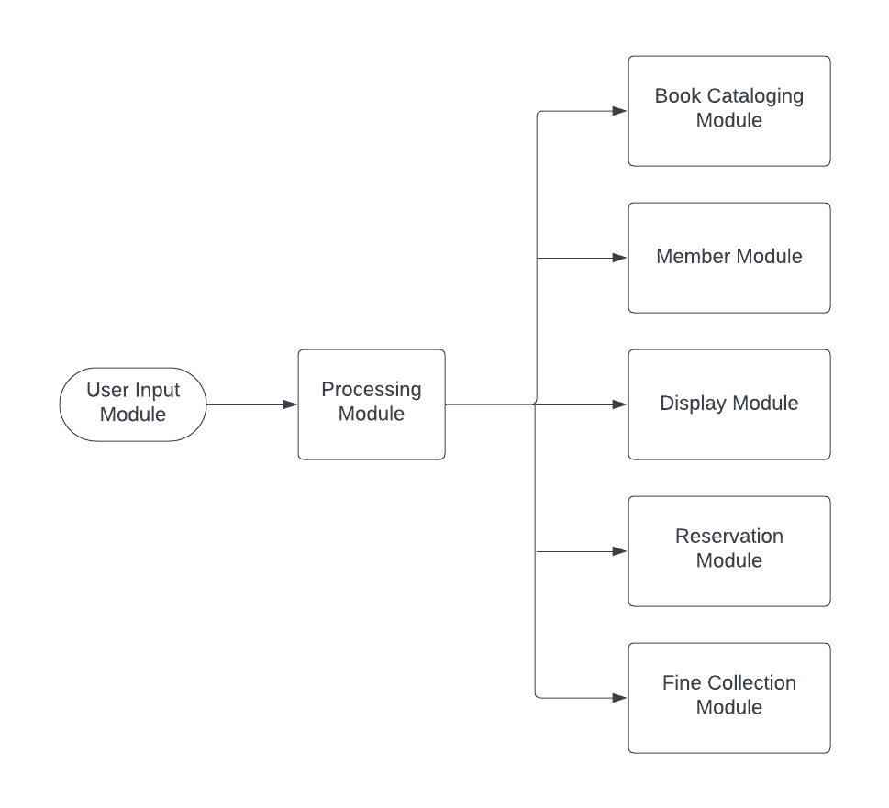

*Figure-5.1:System Design*

**1. User Input Module**

This module is responsible for interacting with users and collecting their input to execute various functionalities of the library system. It presents a user-friendly menu-driven interface using print statements and takes user input through the `input()` function. The user's choices determine which actions are performed within the system, such as adding books, members, borrowing or returning books, displaying information, and more.

A use case diagram for the Library Management System can represent the interactions between different modules or components. In this case, we can depict three main modules: Input Module, Processing Module, and Display Module. Here's how the use case diagram

**2. Processing Module**

The processing module serves as the core engine of the system. It contains the main control flow and orchestrates interactions between different modules. It interprets user input and invokes relevant methods from other modules to perform the requested operations, like borrowing or returning a book, adding a new member, reserving a book, calculating fines, and more. It ensures that the appropriate actions are taken based on the user's commands.

**3. Book Cataloging Module**

This module handles the storage and management of book-related information. It uses a list to maintain the catalog of books available in the library. It defines the `Book` class, which encapsulates details like the book's title, author, availability status, and reservation information. The module provides methods to add new books to the catalog and display the current list of available books.

**4. Reservation Module**

The reservation module is responsible for managing book reservations by library members. It allows users to reserve available books, marking them as reserved and associating the reserving member's information with the book. It provides functions to reserve a book and cancel a reservation, updating the book's status accordingly.

**5. Fine Collection Module**

The fine collection module is tasked with calculating and managing fines for overdue books. It checks the due date of borrowed books, calculates the fine amount based on the number of days overdue, and updates the member's fine balance. This module ensures accurate fine calculation and prompt reporting to the user.

**6. Display Module**

The display module is responsible for presenting information to the user in a clear and organized manner. It offers methods to display the library catalog, list of borrowed books for a member, and the total fine amount for a member. The display is formatted neatly using string formatting techniques, making it easy for users to comprehend the presented data.

**7.Member Module**

The member module handles the storage and management of member-related details. It defines the `Member` class, which stores information about library members, such as their name, address, borrowed books, and reserved books. This module provides functions to add new members to the library, list the books a member has borrowed, and display the total fine amount for a member.

**5.2 Use Case diagram**

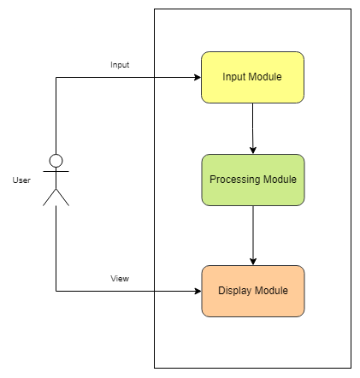

*Figure-5.2:Use Case Diagram*

**1.Input Module**

The provides methods to add books and members, borrow, return, reserve, and cancel reservations of books, calculate fines for overdue books.

**2.Processing Module**

The handles the core functionalities of the library management system, such as checking if a book or member exists, whether a book is available for borrowing or reservation, processing the borrowing and returning of books, managing reservations, and calculating fines.

**3.Display Module**

The is responsible for presenting the library catalog and the list of borrowed books for a particular member.

**Chapter 6**

**Algorithm and Code Snippets**

**Algorithm**

1.Initialize the Library with an empty catalog of books and an empty list of members.

2.Display a welcome message and show the menu of options.

3.Allow the user to choose from the menu until they decide to exit.

4.For each option selected:

1. If the user chooses to add a book, prompt for the title and author, and add the book to the catalog.
2. If the user chooses to add a member, prompt for the name and address, and add the member to the list of members.
3. If the user chooses to display the catalog, iterate through the catalog and display the book details.
4. If the user chooses to display a member's borrowed books, search for the member and display their borrowed books.
5. If the user chooses to borrow a book, search for the member and the book, and mark the book as borrowed by the member.
6. If the user chooses to return a book, search for the member and the book, and mark the book as returned by the member. Ask for the issued date and due date to calculate fines if overdue.
7. If the user chooses to reserve a book, search for the member and the book, and mark the book as reserved by the member.
8. If the user chooses to cancel a reservation, search for the member and the book, and cancel the reservation.
9. If the user chooses to calculate fines, search for the member and calculate fines based on overdue books.
10. If the user chooses to exit, display a goodbye message and end the program.

**Code Snippets**

**1.**The following method allows the admin to add a book to the existing library.

|  |
| --- |
| def add_book(self, title, author):  book = Book(title, author)  self.catalog.append(book) |

**2.**The following method is used to add a member or a user to the system.

|  |
| --- |
| def add_member(self, name, address):  member = Member(name, address)  self.members.append(member) |

**3.** The following method used to display the catalog of books in a tabular format.

|  |
| --- |
| def display_catalog(self):  try:  print("Library Catalog:")  print("{:<30} {:<30} {:<15}".format("Title", "Author", "Availability"))  print("="*75)  for book in self.catalog:  availability = "Available" if book.available else "Not Available"  print("{:<30} {:<30} {:<15}".format(book.title, book.author, availability))  except Exception as e:  print("Error occurred while displaying the catalog:", e) |

**4.** The following method is used to display the list of borrowed books by the member.

|  |
| --- |
| def display_member_borrowed_books(self, member_name):  for member in self.members:  if member.name.lower() == member_name.lower():  print(f"Borrowed Books for {member.name}:")  if member.borrowed_books:  for book in member.borrowed_books:  print("Title:", book.title)  print("Author:", book.author)  print("-----------")  else:  print("No books borrowed.")  return  print("Member not found.") |

**5.** The following method is used to borrow a book from the system by giving credentials like name and book title.

|  |
| --- |
| def borrow_book(self, member_name, book_title):  for member in self.members:  if member.name.lower() == member_name.lower():  for book in self.catalog:  if book.title.lower() == book_title.lower() and book.available:  member.borrowed_books.append(book)  book.available = False  print("Book borrowed successfully.")  return  print("Book is not available for borrowing.")  return  print("Member not found.") |

**6.** The following snippet is used to return a book back to the library and checks for overdue to pay fine.

|  |
| --- |
| def return_book(self, member_name, book_title):  for member in self.members:  if member.name.lower() == member_name.lower():  for book in member.borrowed_books:  if book.title.lower() == book_title.lower():  try:  issued_date_str = input("Enter the issued date (YYYY-MM-DD): ")  due_date_str = input("Enter the due date (YYYY-MM-DD): ")  issued_date = date.fromisoformat(issued_date_str)  due_date = date.fromisoformat(due_date_str)  # Compare the dates to check if the book is overdue  today = date.today()  if today > due_date:  days_overdue = (today - due_date).days  fine_amount = days_overdue * 3 # Fine of ₹3 per day for overdue books  print(f"Book is overdue. Fine: ₹{fine_amount}")  member.borrowed_books.remove(book)  book.available = True  print("Book returned successfully.")  return  except ValueError:  print("Invalid date format. Please use YYYY-MM-DD.")  return  print("Book is not borrowed by this member.")  return  print("Member not found.") |

**7.** The following method is used to reserve a book which has been borrowed before.

|  |
| --- |
| def reserve_book(self, member_name, book_title):  for member in self.members:  if member.name.lower() == member_name.lower():  for book in self.catalog:  if book.title.lower() == book_title.lower() and book.available:  member.reserved_books.append(book)  book.available = False  book.reserved_by = member  print("Book reserved successfully.")  return  print("Book is not available for reservation.")  return  print("Member not found.") |

**8**. The following method is used to cancel the reservation made by the member.

|  |
| --- |
| def cancel_reservation(self, member_name, book_title):  for member in self.members:  if member.name.lower() == member_name.lower():  for book in member.reserved_books:  if book.title.lower() == book_title.lower():  member.reserved_books.remove(book)  book.available = True  book.reserved_by = None  print("Reservation canceled successfully.")  return  print("This book is not reserved by the member.")  return  print("Member not found.") |

**9**. The following method is used to calculate the fine for the overdue books.

|  |
| --- |
| def calculate_fine(self, member_name):  for member in self.members:  if member.name.lower() == member_name.lower():  fine_amount = 0  today = date.today()  for book in member.borrowed_books:  if not book.available:  due_date = today - timedelta(days=14) # Assuming the due date is 14 days from borrowing  days_overdue = (today - due_date).days  fine_amount += days_overdue * 3 # Fine of ₹3 per day for overdue books  print(f"Total Fine for {member.name}: ₹{fine_amount}")  return  print("Member not found.") |

**Chapter 7**

**Testing**

To thoroughly test the Library Management System, we can cover various scenarios to ensure the code works correctly and handles different situations gracefully. Here are some test cases to consider:

|  |  |  |  |  |
| --- | --- | --- | --- | --- |
| **Test Case No** | **Test Case Description** | **Expected Input** | **Expected Output** | **Pass/Fail** |
| 1. | Add various Books and Members | Various Books and Members Added | Pass | Pass |
| 2. | Display Catalog | Various Books are displayed | Pass | Pass |
| 3. | Borrow Book that is available in catalog | Member name and Book name | Pass | Pass |
| 4. | Members and Books not found | Members and books not added yet | Fail | Pass |
| 6. | Return Book | Book name, issued date, due date | Pass | Pass |
| 7. | Cancel Reservation | Returning Book | Pass | Pass |
| 8. | Calculate Fine | Member name and Book name, if not exceeded bue date | Pass | Pass |
| 9. | Book not returned (exceeded due date) | Fine Caculation 3rs per day/book | Fail | Pass |
| 10. | Display Member's Borrowed Books | Member name | Pass | Pass |

**Chapter 8**

**Results and Snapshots**

**Snapshot-1:** Books are added to the existing library system.

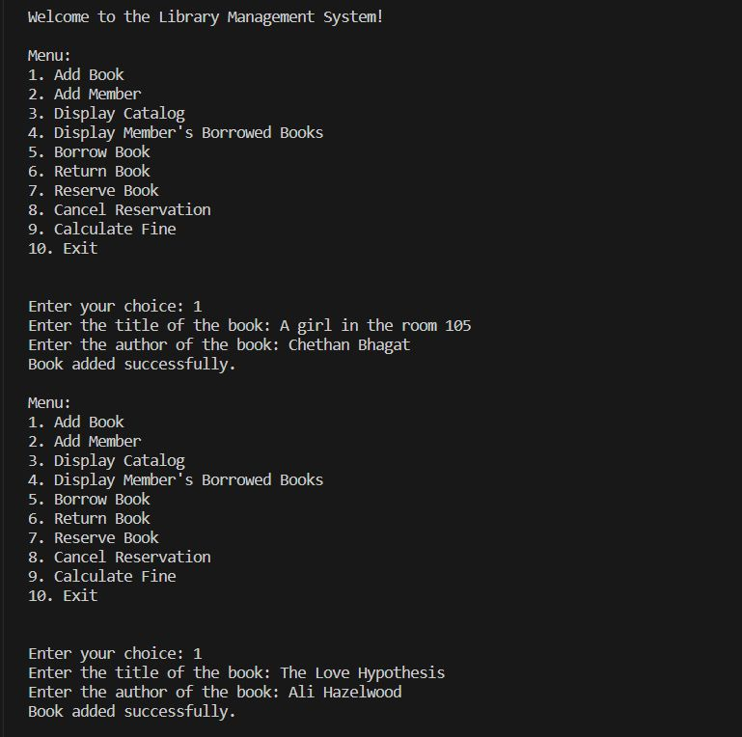

*Figure-7.1:Books are added to the existing library*

**Snapshot-2:** Books are added to the existing library system.

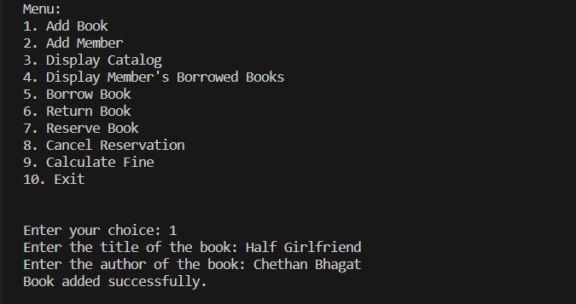

*Figure-7.2:Books are added to the existing library*

**Snapshot-3:** Members are added to the existing library system and display book catalog.

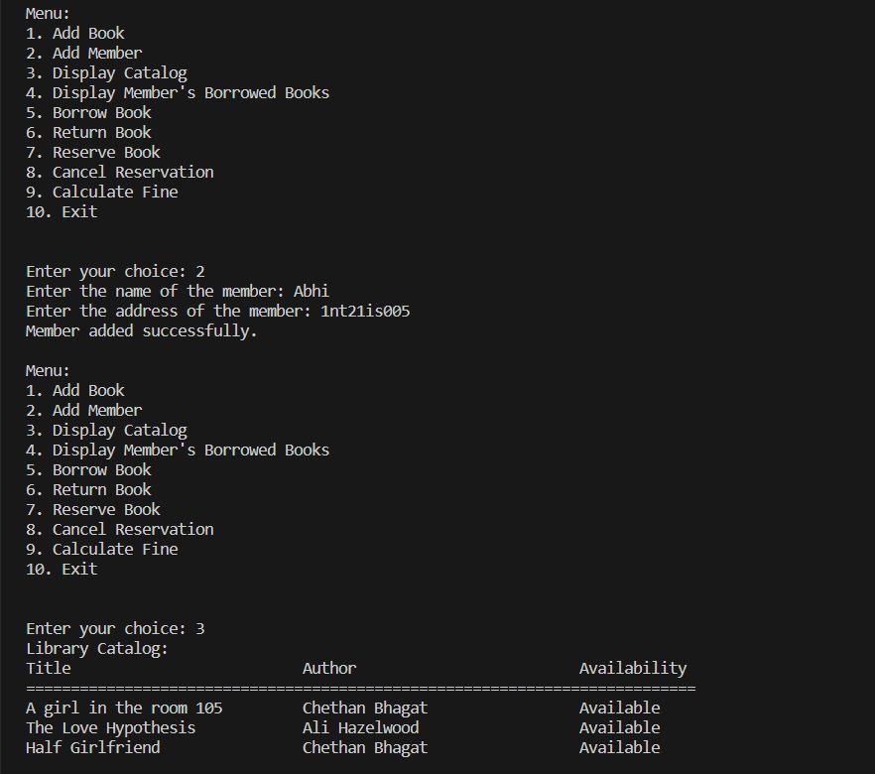

*Figure-7.3:Members are added to the existing library and display catalog*

**Snapshot-4:** Book is borrowed and display borrowed book of a member

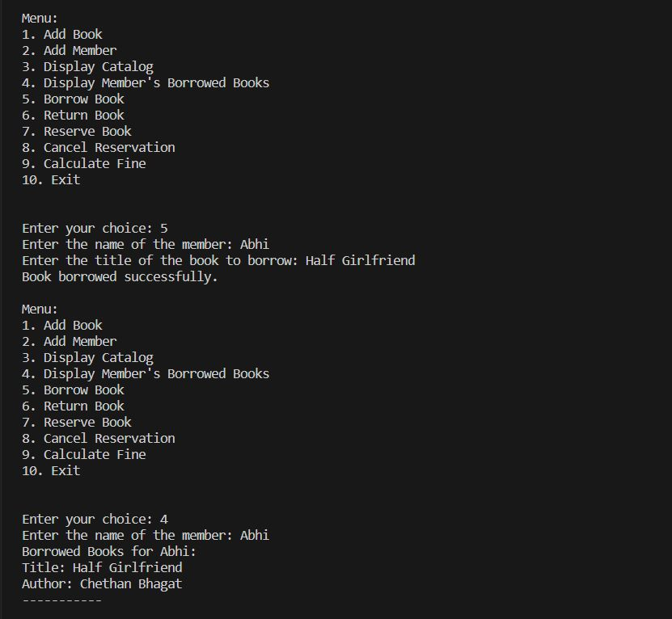

*Figure-7.4:Books are borrowed and display borrowed book*

**Snapshot-5:** Book is Returned and Reservation of book

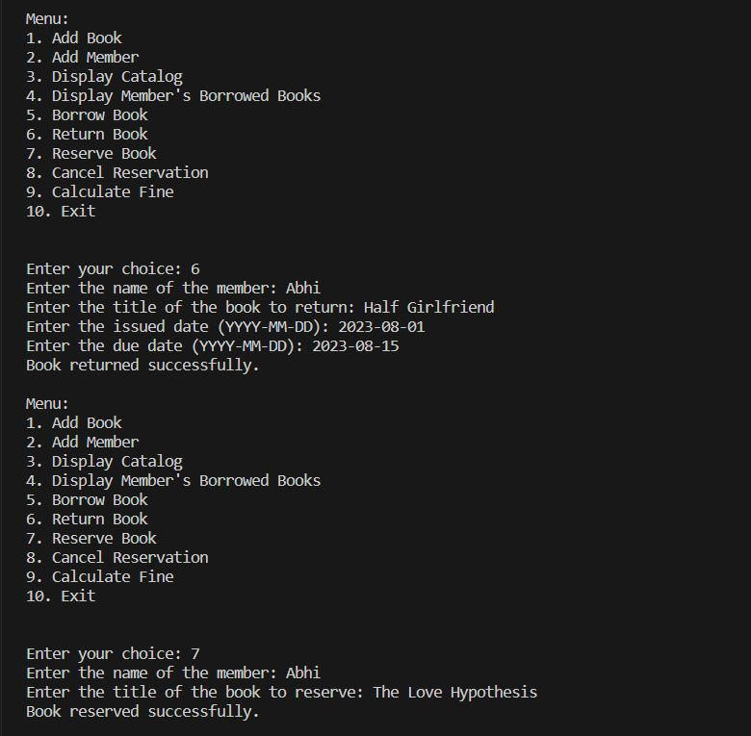

*Figure-7.5:Return book and Reserve Book*

**Snapshot-6:** Fine display and borrow book (Exception)

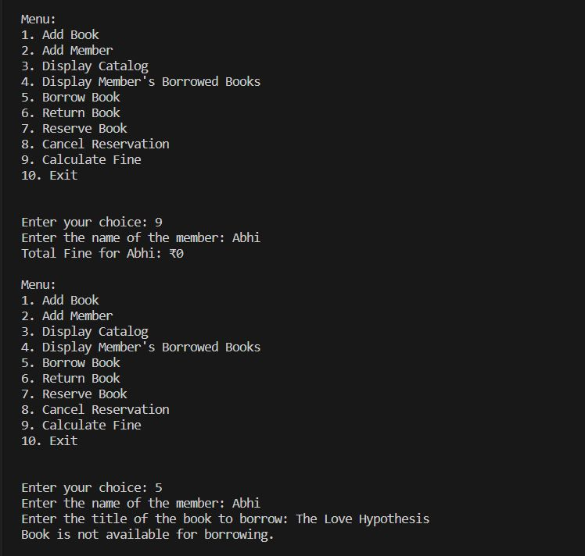

*Figure-7.6:Fine display and borrow book(exception)*

**Snapshot-7:** Book is returned late and Fine is calculated

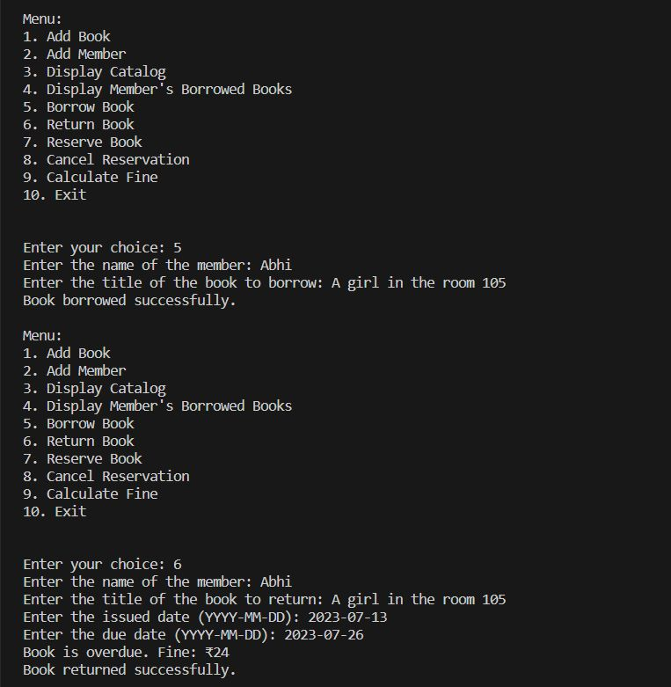

*Figure-7.7:Fine calculation*

**Snapshot-8:** Cancel Reservation and exit

**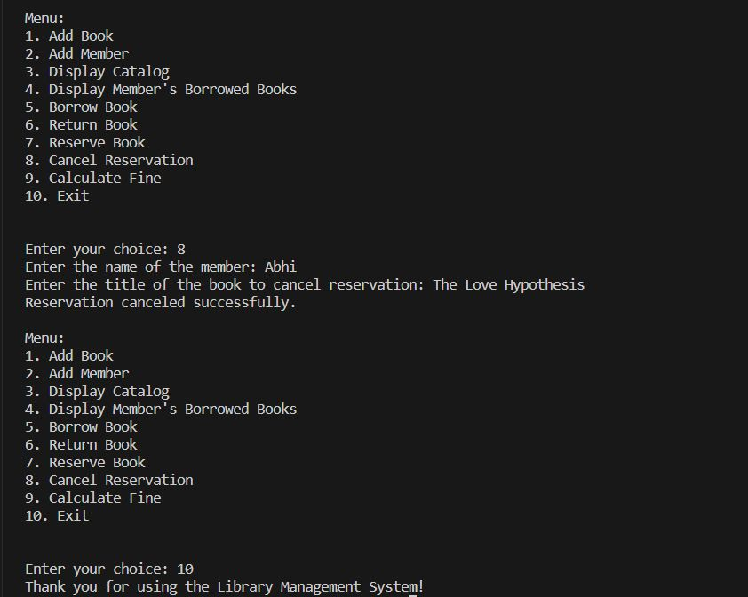***Figure-7.8:Cancel Reservation*

**Chapter-9**

**Conclusion**

In conclusion, while the Library Management System code presented here offers a simple and interactive text-based interface for library operations, it should be recognized that this implementation is basic and lacks certain features essential for real-world use. For instance, further development is required to integrate databases for persistent data storage, ensure user authentication and security measures, and implement advanced reservation algorithms. Additionally, to enhance user interactions, a graphical user interface (GUI) could be introduced. Nevertheless, the code's modularity through classes enables ease of understanding, maintenance, and future expansion, making it a good starting point for building a functional and user-friendly library management system tailored to specific requirements and user preferences.

**References and Bibliography**

* **The Python documentation**: https://docs.python.org/3/
* **The Stack Overflow**: https://stackoverflow.com/ website
* **The Real Python**: https://realpython.com/ website